NATIONAL TECHNICAL UNIVERSITY OF UKRAINE

“Igor Sikorsky KYIV POLYTECHNIC INSTITUTE”

Faculty of Applied Mathematics

Department of Computer Systems Software

Course project

of the discipline "Technologies of Software System Design"

titled

““An Application For Array Sorting and Matrix Operations””

Done by Cemal Cem TASTAN

student of study group КП-92M

Project curator

senior teacher Ruslan Hadyniak

Points

___________________________

(signature)

Kyiv 2019

Contents

**Course Project Task Variant** 4

**Requirements and Analysis** 4

**2.1. Multiplication Algorithm** 5

**2.2. Add Algorithm** 6

**2.3. Transpose Algorithm** 7

**2.4. Bubble Sort Algorithm** 7

**Result** 9

**Add Algorithm** 9

**Transpose Algorithm** 10

**Bubble Sort Algorithm** 10

**Summary** 11

Figure 1 matrix2.json 3

Figure 2The whole project is have six different files. 3

Figure 3 json files 4

Figure 4 multiply function 5

Figure 5 addition function 5

Figure 6 transpose function 6

Figure 7 bubble sort function 7

Figure 8 export 7

Figure 9 import 8

Figure 10 multiply result 8

Figure 11addition result 9

Figure 12 array sorting by bubble 10

# **Course Project Task Variant**

* User interaction type: **full command strings**
* Matrix operations: **adding, multiplication, transpose**
* Sorting algorithm: **bubble**

# **Requirements and Analysis**

In this section, project’s requirements will be determined and related analysis will be considered. The purpose of this project is to perform predetermined mathematical operations and sort using the user's matrices and array.  
  
 To be easy to understand, mathematical functions, sort function, matrices, array and the main program will be in separate titles.

The whole project is have six different files. The main file app.js which main program is taking place, the function file functions.js and sort.function.js which handles all the function running on the app.js. The fun.js , sortFunction.js and the app.js are linked with export and import methods.

matrix1.json

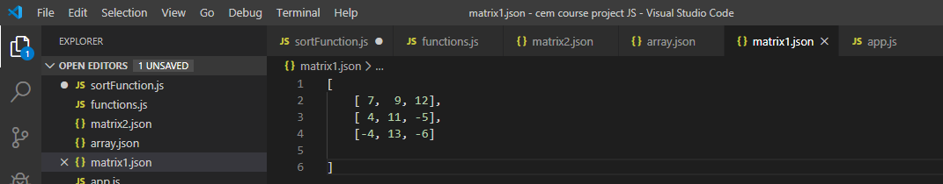

Figure matrix2.json

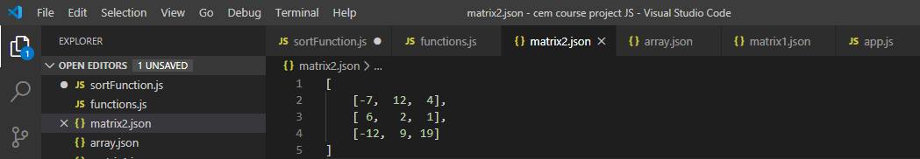

Figure The whole project is have six different files.

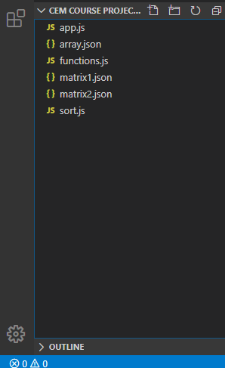

Figure json files

# **2.1. Multiplication Algorithm**

-The user will call 2 matrices created to perform multiplication. (matrix1.json and matrix2.json)

-In order to perform multiplication in matrices, code was written to check whether the number of columns of the first matrix and the number of rows of the second martis are equal.

-If the number of columns of the first matrix is not equal to the number of rows of the second matrix, the program will output “can not multiply this matrices ".

-A new matrix was created to assign the values that will occur as a result of multiplication.

* The command (node app.js matrix multiply matrix1.json matrix2.json)

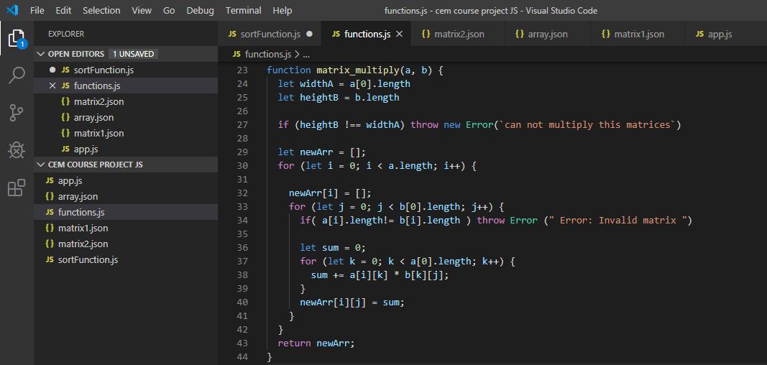

Figure multiply function

# **2.2. Add Algorithm**

-The user will call 2 matrices created to perform addition. (matrix1.json and matrix2.json)

-In order to perform addition operation in matrices, code was written to check whether two matrices have the same number of rows and columns.

-If the two matrices that are going to be processed are not equal in size, the code that gives error output is written as a “if”.

* The command (node app.js matrix add matrix1.json matrix2.json)

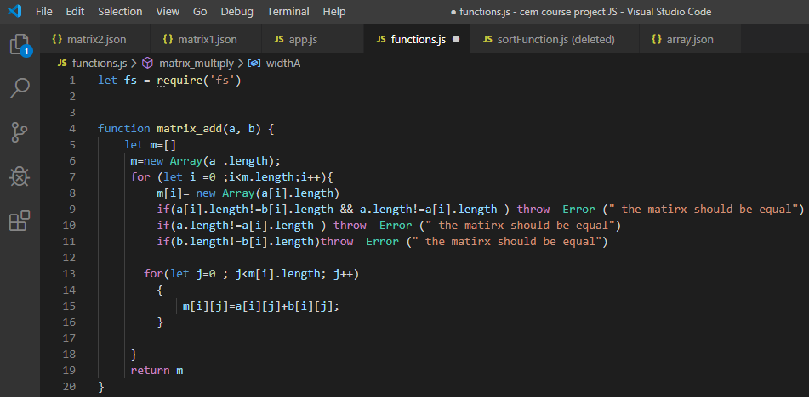

Figure addition function

# **2.3. Transpose Algorithm**

-In order to perform this operation, the selected matrix must be square matrix.

-If the selected matrix is not a square matrix, the output will be "invalid matrix: it should be a square matrix" error.

-The user will select a matrix to perform transpose (matrix1.json or matrix2.json)

-Written code to replace the row and column values of the selected matrix.

* The command (node app.js matrix transpose matrix1.json)
* The command (node app.js matrix transpose matrix2.json)

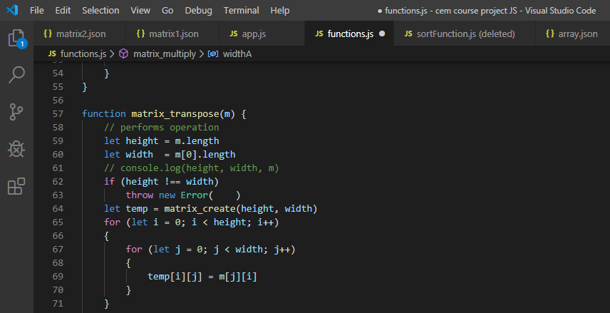

Figure transpose function

# **2.4. Bubble Sort Algorithm**

-Was created an one dimensional array to implement this algorithm.

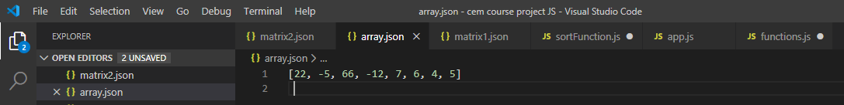

-By using this algorithm user will sort that array.

* The command (node app.js array sort array.json)

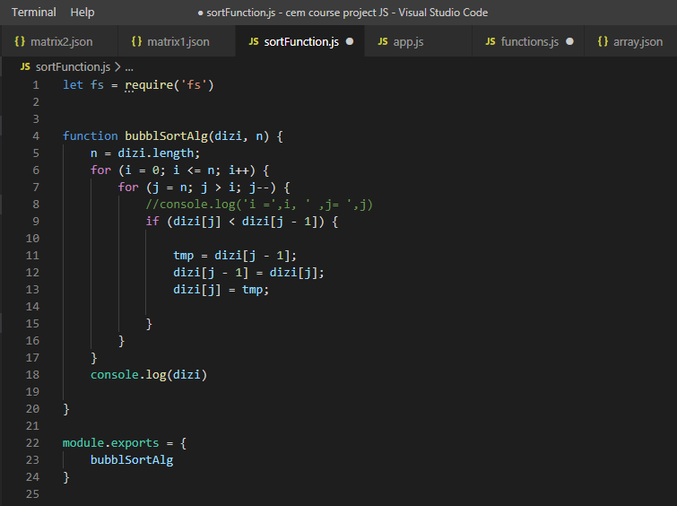

Figure bubble sort function

Here you can see export of functions.js to implement in app.js

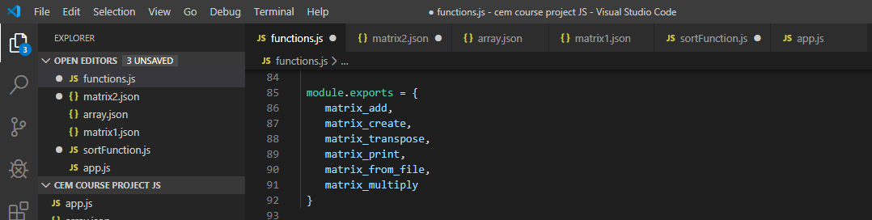

Figure export

Here you can see export of sortFunction.js to implement in app.js

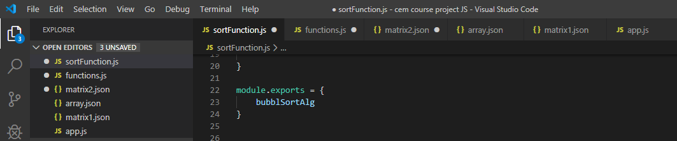

The exported files are again imported to where needed in this case to app.js. And how to import is shown on below screen shot.

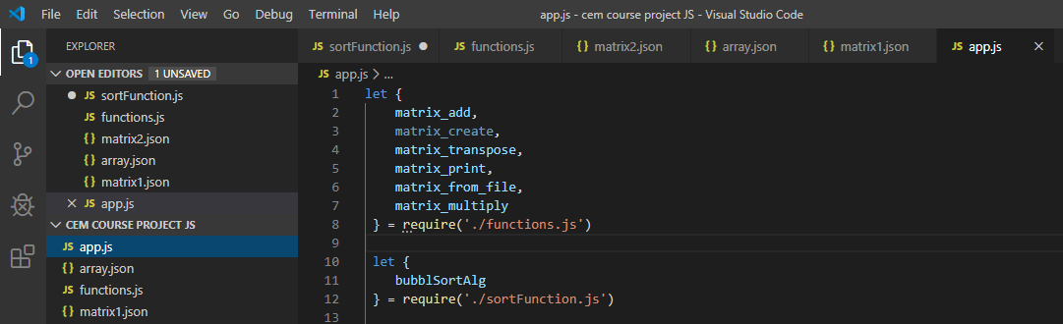

Figure import

# **Result**

**Multiplication Algorithm**

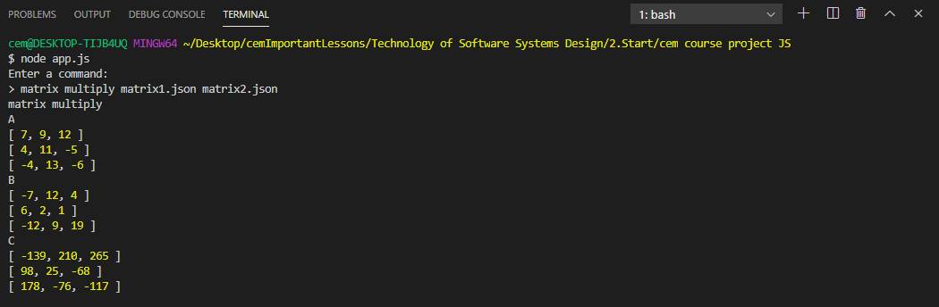

Figure multiply result

# **Add Algorithm**

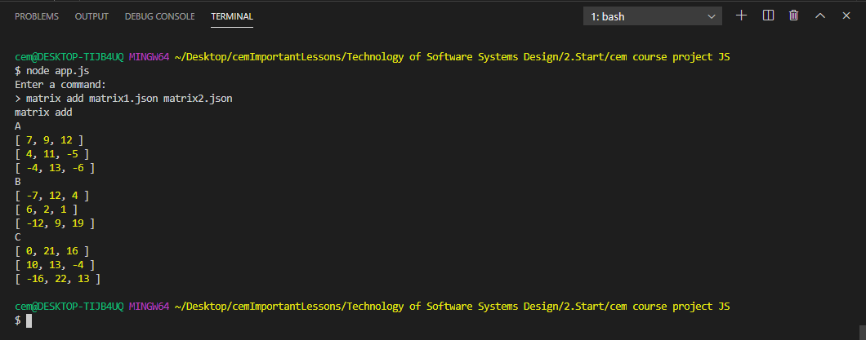

Figure addition result

# **Transpose Algorithm**

matrix1.json

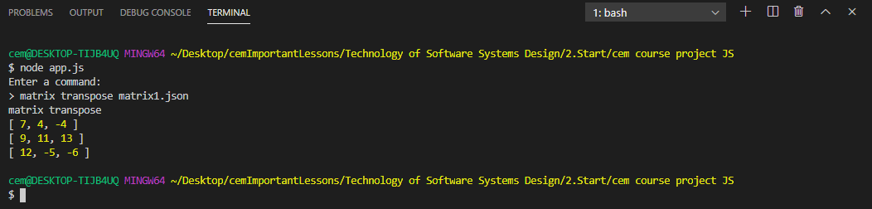

matrix2.json

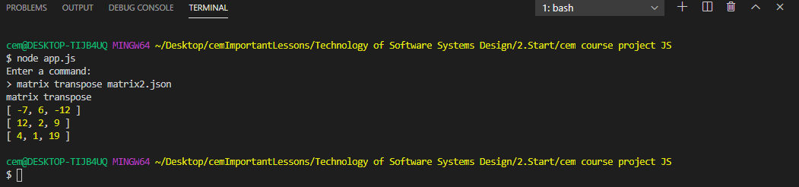

# **Bubble Sort Algorithm**

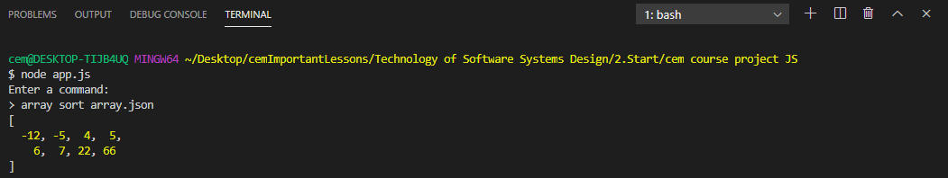

Figure array sorting by bubble

# **Summary**

The aim of the project is to create general functions, to call them and apply them to matrices and arrays, to provide the program where the user can achieve accurate results.